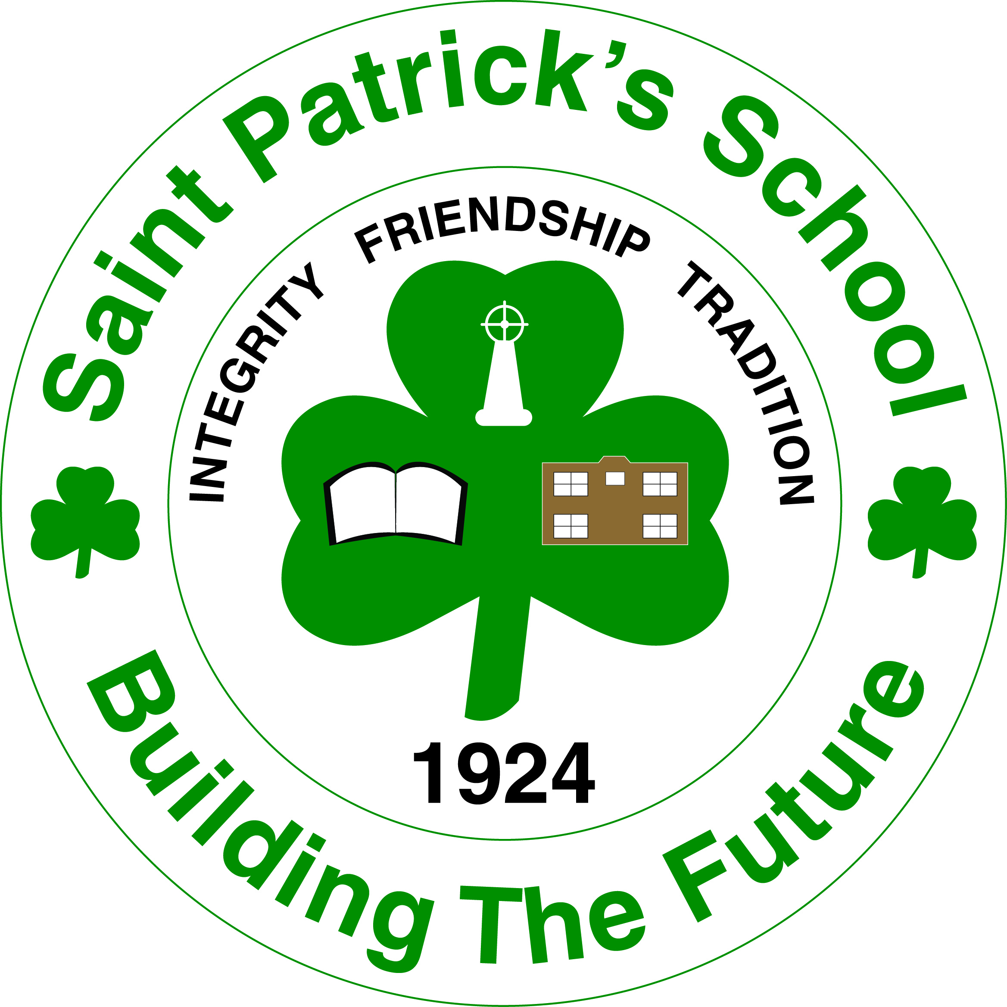
Saint Patrick’s School
172 City Line, Saint John, NB E2M 1L3 Phone: (506) 658-5362 – Fax: (506) 658-6323
Principal: Michael Wilson Acting Vice Principal: Rosalyn Nickerson

Hot Lunch: Beginning Tuesday, January 31, 2012 pasta and spaghetti sauce will be available on Tuesday’s for $1.25. Soup will be served on Wednesday, free of charge, compliments of our PALS from Hillcrest Baptist Church. If Wednesday is ever a storm day soup will be served on Thursday.
Newcomb Ball Jamboree: Tuesday, February 7th from 3:30-5:15 @ Island View School.

March Break: March break is from March 5th-9th. Students return to school on March 12th.

Lending Library: Every Tuesday from 1:35-2:00& 2:35-3:00, books and games are available to be borrowed by parents and students.

Literacy Website: St. Patrick’s School has a new Literacy Website! If you are looking for extra help with reading and writing, new ideas to encourage literacy in your household, new word games, or if you just want to watch a few videos and check out the newest writing challenge, this is the place to go. Find it at www.stpatricksliteracy.weebly.com . We encourage all parents to visit and come back often.
Kindergarten Registration: If you have a child that will be turning 5 years old before December 31, 2012 and they have not yet registered for kindergarten for September, please contact the school @ 658-5362.

School Wide Science Fair: There is something exciting coming to St. Patrick’s School in February! It’s scientifically fun and the whole school will participate! If goo is for you, then come join us for the Science Fair! Mr. Wilson will be sending a notice home soon that will provide more information.

